**Use these Docker containers to manage your entire digital life**

Story by Parth Shah

I have always been interested in finding a better way to manage my digital life. I have tried countless apps, services, and platforms, but nothing felt quite right. Then I discovered Docker. I started as a way to containerize a few small projects, and it quickly evolved into a complete overhaul of how I run my digital life.

Now, everything from my personal cloud storage to my project manager runs in its own isolated container and gives me unparalleled control, privacy, and flexibility. Let me walk you through my entire setup and show you how I use these Docker containers to manage my entire digital life.

**HomeBox**

**My personal inventory system**

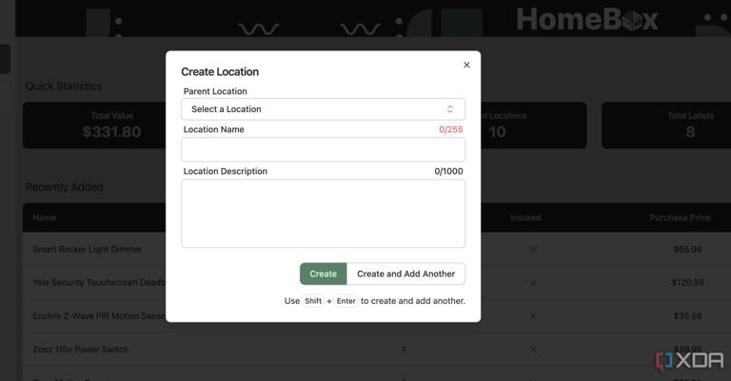

HomeBox create a location

[HomeBox](https://www.xda-developers.com/improved-home-organization-with-free-open-source-tool/?utm_source=syndication&pubDate=20250824) is my go-to inventory and asset management system. Instead of relying on a messy spreadsheet, I use HomeBox to track everything I own, from electronics and tools to books and furniture.

It comes with a decent UI that has no learning curve, offers excellent performance, and ample features to create a private database. For example, when I add a new item, I can insert photos, purchase details, maintenance, and more.

I can even create multiple locations and use tags to organize my items like a pro. There is also a built-in scanner to add items in no time. Overall, HomeBox brings order to my physical world. It helps me avoid unnecessary purchases (do I really need another USB-C cable?) and ensures I can easily find what I need.

**Docmost**

**An ideal Notion clone**

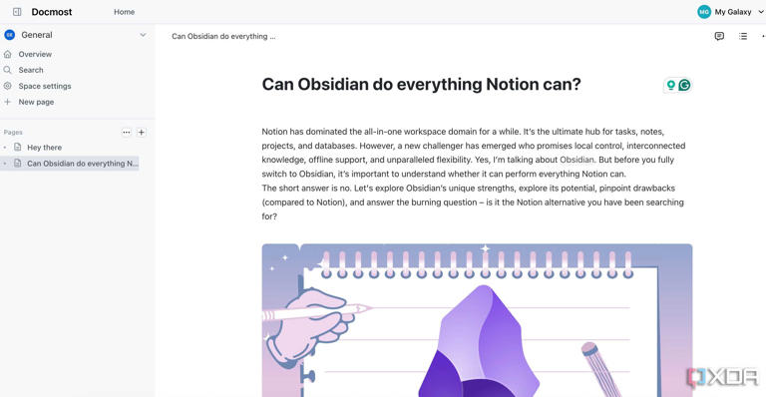

Docmost main menu

[Docmost](https://www.xda-developers.com/found-best-self-hosted-alternative-to-notion-cant-stop-raving-about-it/?utm_source=syndication&pubDate=20250824) isn’t just another note-taking app. It’s a powerful, self-hosted wiki and knowledge management system that has become the central hub for my personal and professional information.

If you have used Notion before, you will feel right at home with Docmost. You can create workspaces, add pages, insert emojis, banners, and take advantage of the block editor to format pages in no time.

I use it for my long-term personal projects, meeting notes, and future blog posts. It even supports file embeds from third-party services like Typeform, Miro, YouTube, Framer, Google Sheets, and Google Drive.

My favorite add-on is support for Mermaid. Instead of using external services like Excalidraw, I can use text-based syntax to insert detailed diagrams right onto my pages. Docmost also supports real-time collaboration, where I can share documents with others seamlessly.

**Nextcloud**

**OneDrive, who?**

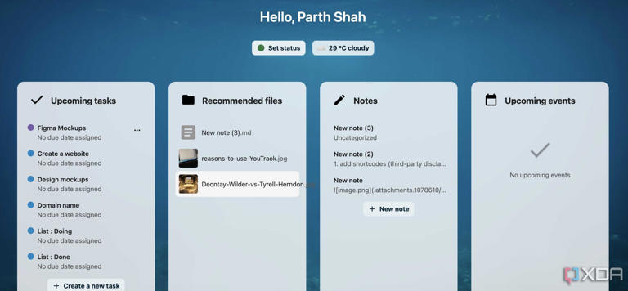

Nextcloud dashboard

[Nextcloud](https://www.xda-developers.com/nextcloud-beats-microsoft-365-entirely-for-free/?utm_source=syndication&pubDate=20250824) doesn’t require an introduction if you have been into self-hosting for a while. It’s not just a file-syncing service; Nextcloud is an all-in-one personal cloud that handles everything from file storage to calendar and contact management.

Nextcloud has native apps on all the major platforms. Even the web app is quite capable with a fully customizable dashboard. I can add multiple widgets like email, contacts, tasks, and media to check everything at a single glance.

The media management is solid as well. I can create folders, utilize tags, filter them by locations, and even use the superior sharing permissions like password-protection and expiry date to have peace of mind.

**Kavita**

**Track your favorite books**

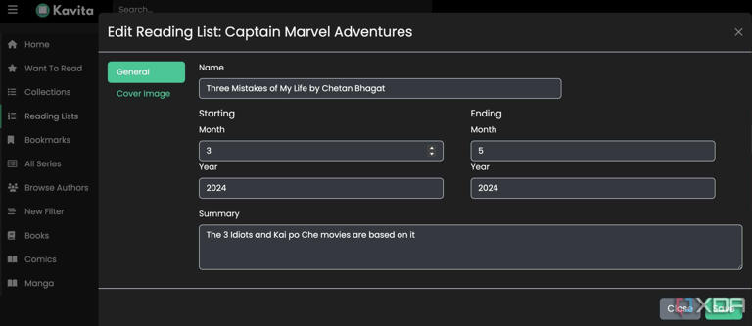

Kavita app

Reading has always been a huge part of my life. But it’s never an easy task to manage my ever-growing collection of ebooks, comics, and manga. I tried storing files on my computer, but it didn’t offer the seamless, unified experience I was looking for.

Kavita is designed specifically for handling books, comics, and manga. The homepage is completely customizable. The list of features includes extensive file support, a robust comic reader with full screen mode, reading direction, book reader, PDF reader, and more.

**Tududi**

**Fly through your projects and tasks**

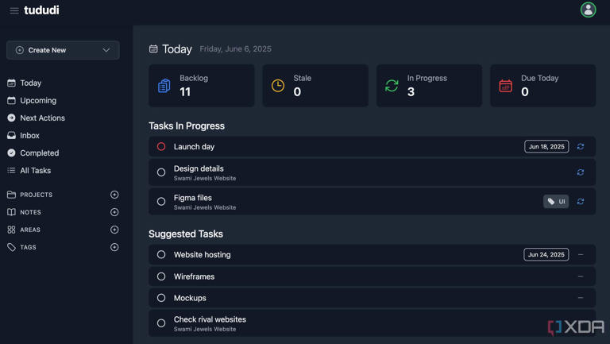

Tududi dashboard

[Tududi](https://www.xda-developers.com/free-open-source-to-do-list-tracker-has-changed-my-life/?utm_source=syndication&pubDate=20250824) is my favorite Docker container of the bunch. I have tried several task managers, but they all eventually fell short. Tududi isn’t just a simple to-do list. It offers a powerful and flexible task and project management tool.

First of all, the user interface is really solid with neat icons. I can see my today’s, upcoming, and entire inbox right from the sidebar. Tududi is ideal for managing projects, too.

I can add different tasks with status, priority, due date, and notes and use tags to organize them like a pro. While Tududi doesn’t rival established players like Trello or Asana, it gets the job done for personal projects.

**Linkding**

**Managing my web bookmarks**

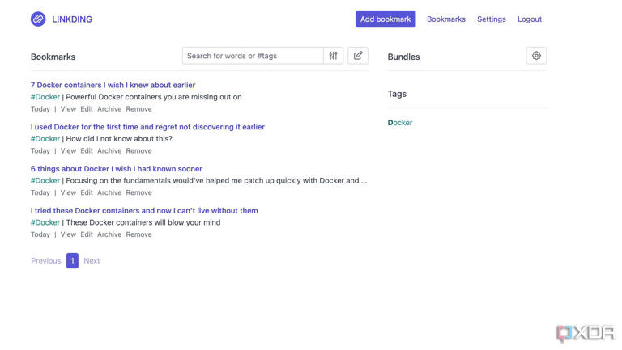

reasons-to-use-Linkding-3

While there are several bookmarking tools out there, I prefer [Linkding](https://www.xda-developers.com/self-hosted-free-bookmark-manager-its-beautifully-simplistic/?utm_source=syndication&pubDate=20250824" \t "_blank) due to its simplicity. It’s fast, minimal, and gets right to the point. When I save a link, I can instantly add tags to it.

I have tags for everything: Raspberry Pi, self-hosting, Docker, AI, and more. Beyond its tagging system, my favorite add-on is the ability to archive a web page. This means that even if the original webpage goes down, I can have a local, private copy of a page.

**The Docker-powered digital life**

Taking back control of your digital life can seem challenging using Docker, but it’s one of the most rewarding things you can do. So what are you waiting for? Start leveraging these Docker containers and build a personal, flexible, and private infrastructure that you own. Meanwhile, check out our dedicated post if you are looking for more such [powerful Docker containers](https://www.xda-developers.com/docker-containers-you-havent-actually-heard-of/?utm_source=syndication&pubDate=20250824).